

**WEEK-6 ASSIGNMENT**

-Riddhima Bhanja

Kalinga Institute of Industrial Technology

Bhubaneswar(Java Track)

INDEX

| **Content** | **Page No.** |
| --- | --- |
| **1. SonarQube Code Coverage** | 1 |
| **2. SonarQube Issues** | 3 |
| **3. System Architecture** | 5 |
| **4. JMeter** | 6 |
| — JMeter Result Tree | 6 |
| — JMeter Summary Report | 6 |
| — Apache JMeter Dashboard | 7 |
| **5. Jacoco Code Coverage** | 9 |
| — API Gateway | 9 |
| — Booking Service | 10 |
| — Flight Service | 10 |
| **6. MongoDB Screenshots** | 11 |
| **7. Postman Screenshots** | 11 |
| — Circuit Breaker | 11 |
| — — Events | 12 |
| — — Status | 12 |
| — Health Checks | 13 |
| — — API Gateway Health | 13 |
| — — Booking Service Health | 13 |
| — — Eureka Server Health | 14 |
| — — Flight Service Health | 14 |
| — Add Flight | 15 |
| — Book Flight | 15 |
| — Cancel Booking | 15 |
| — Get Booking by PNR | 16 |
| — Get Booking History | 16 |
| **8. Email** | 17 |
| — With PDF | 17 |
| — Without PDF | 17 |
| — Fallback Case | 17 |
| **9. Eureka Dashboard** | 17 |

1. SonarQUBE Code Coverage

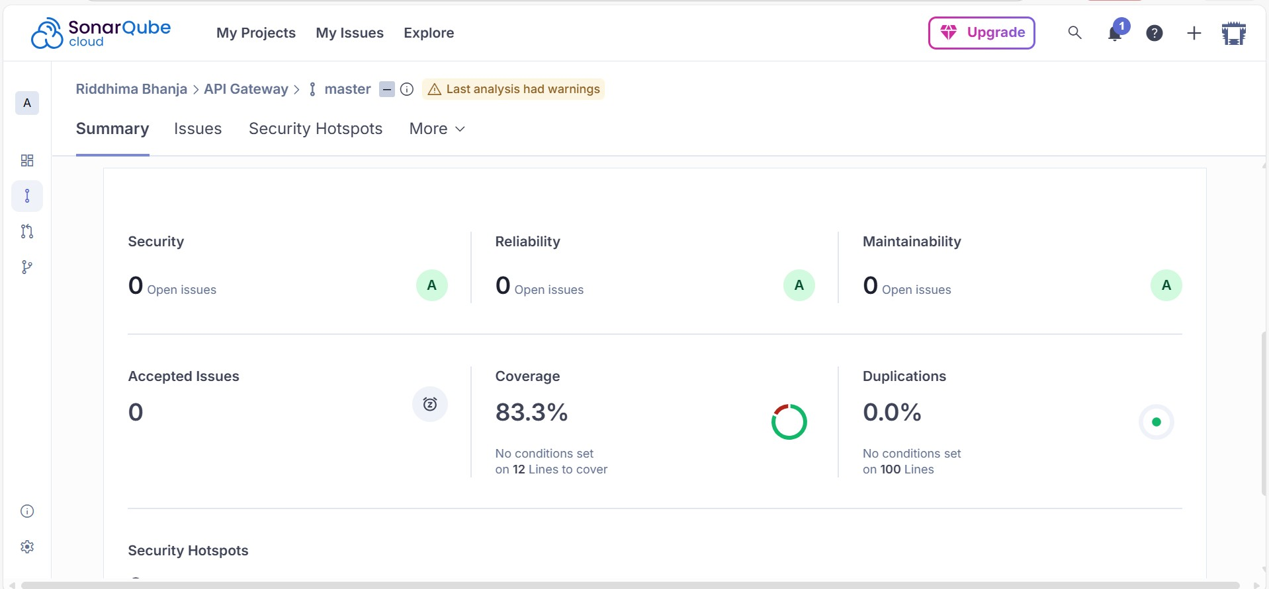

1. SonarQube Issues

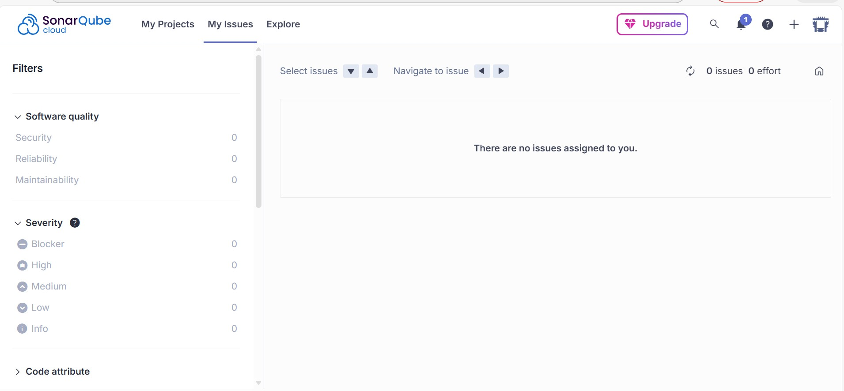

1. System Architecture

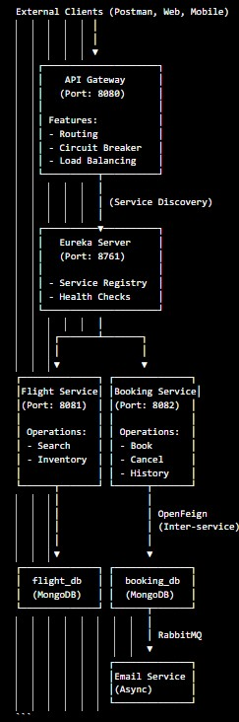

1. Jmeter

* Apache Jmeter Dashboard

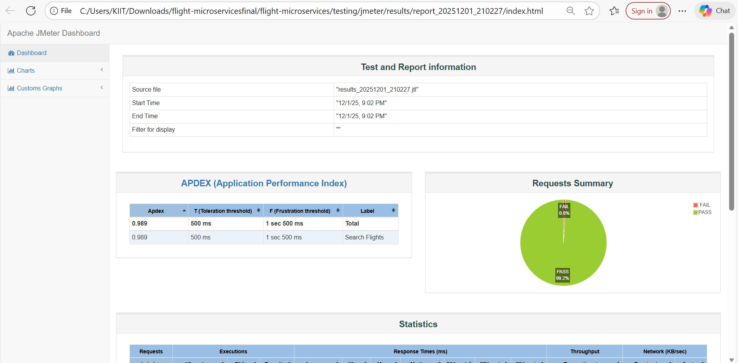

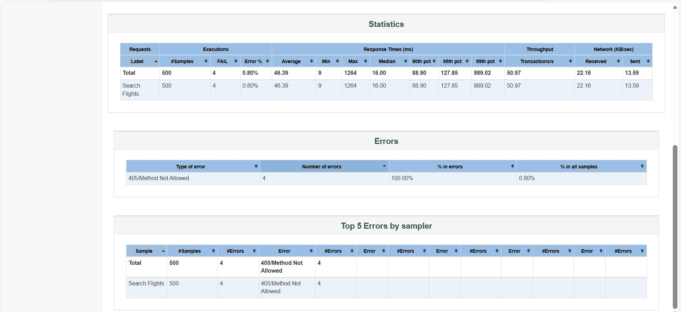

1. Mongodb screenshots

* Booking_db

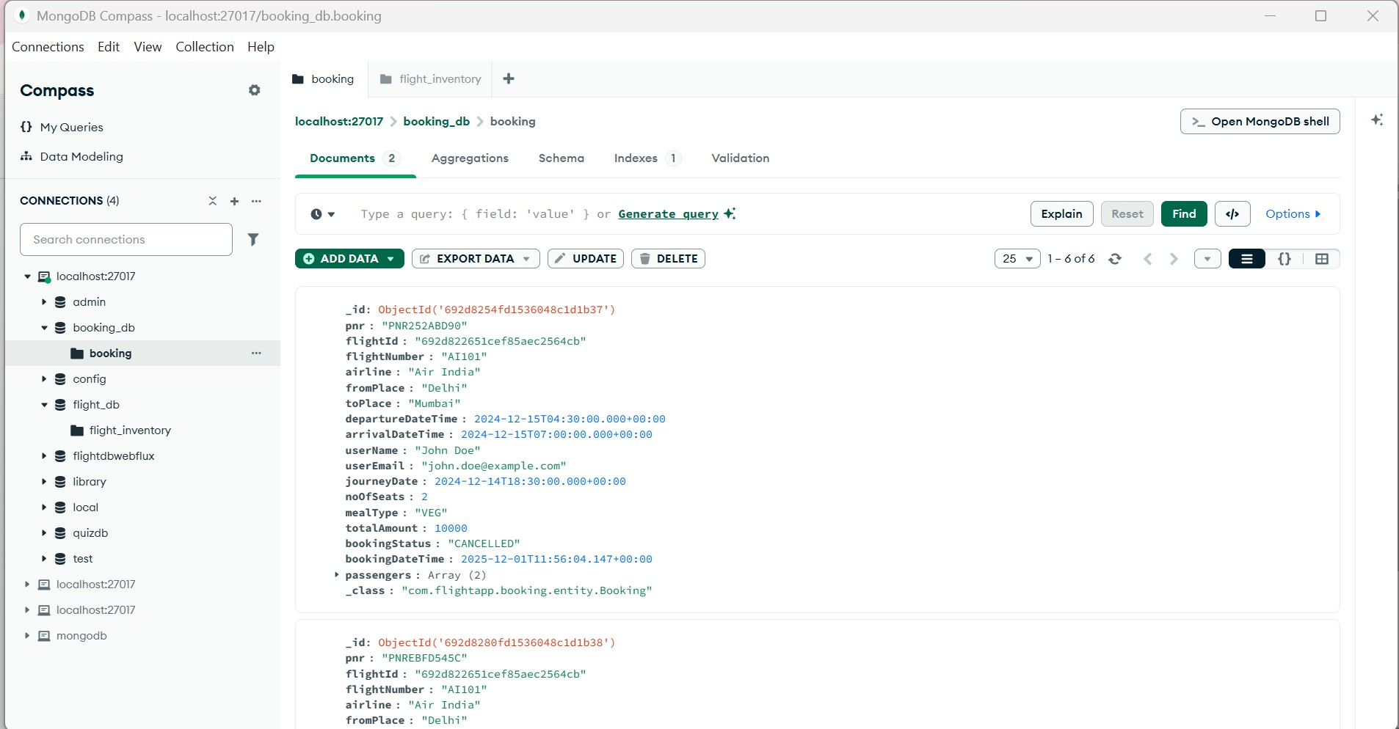

* **Flight_db**

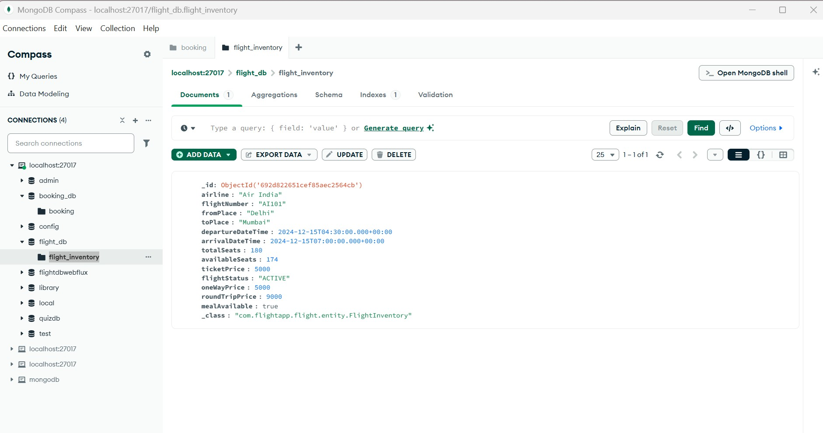

1. Email

* Email with pdf

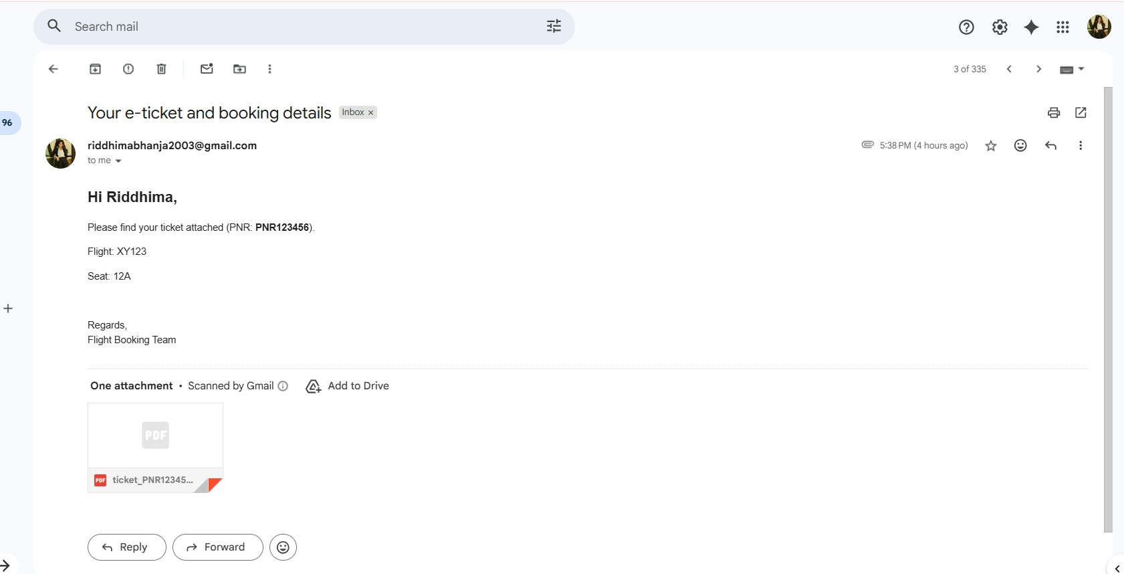

* Email without pdf

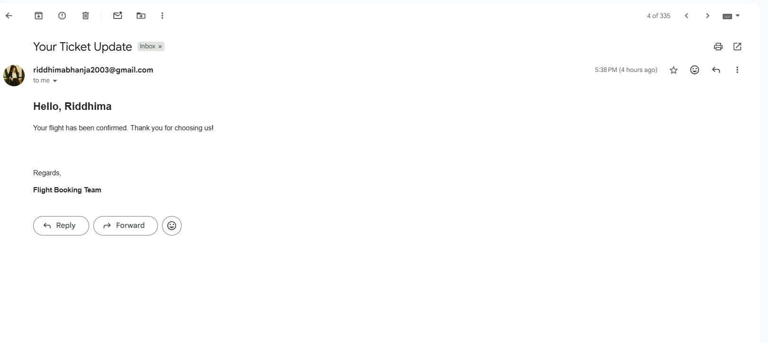

* Flight cancel email

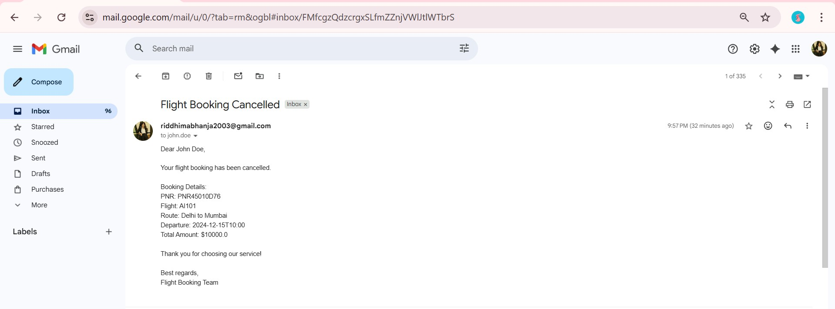

* Flight Confirm email

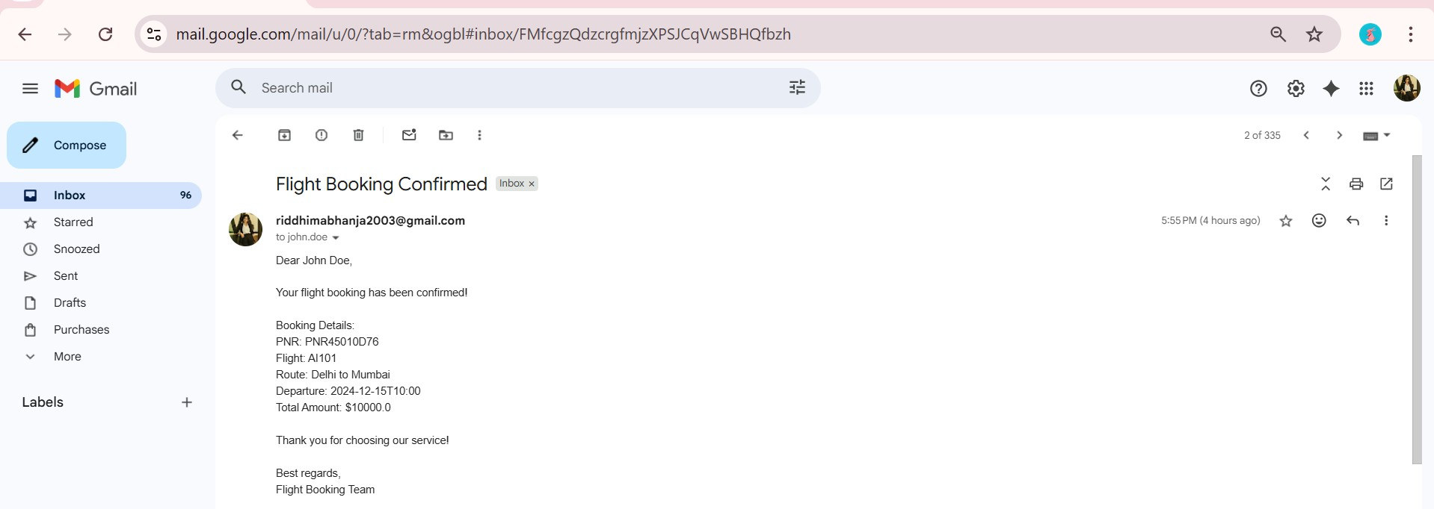

1. Postman screenshots

* **Circuit Breaker**

**Events:**

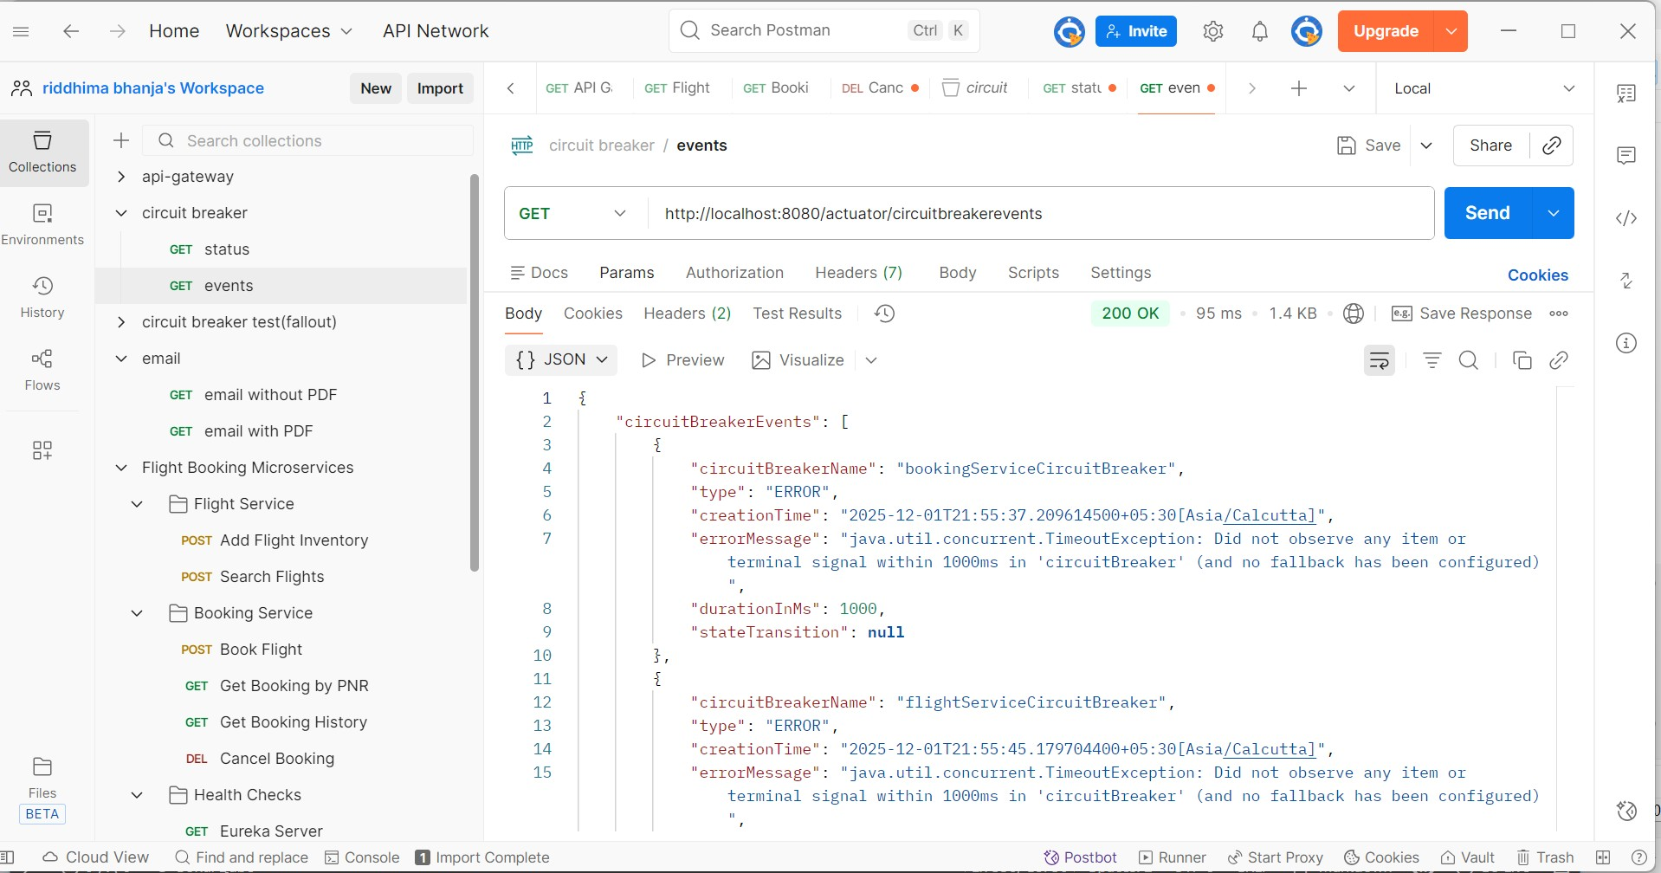

**Status:**

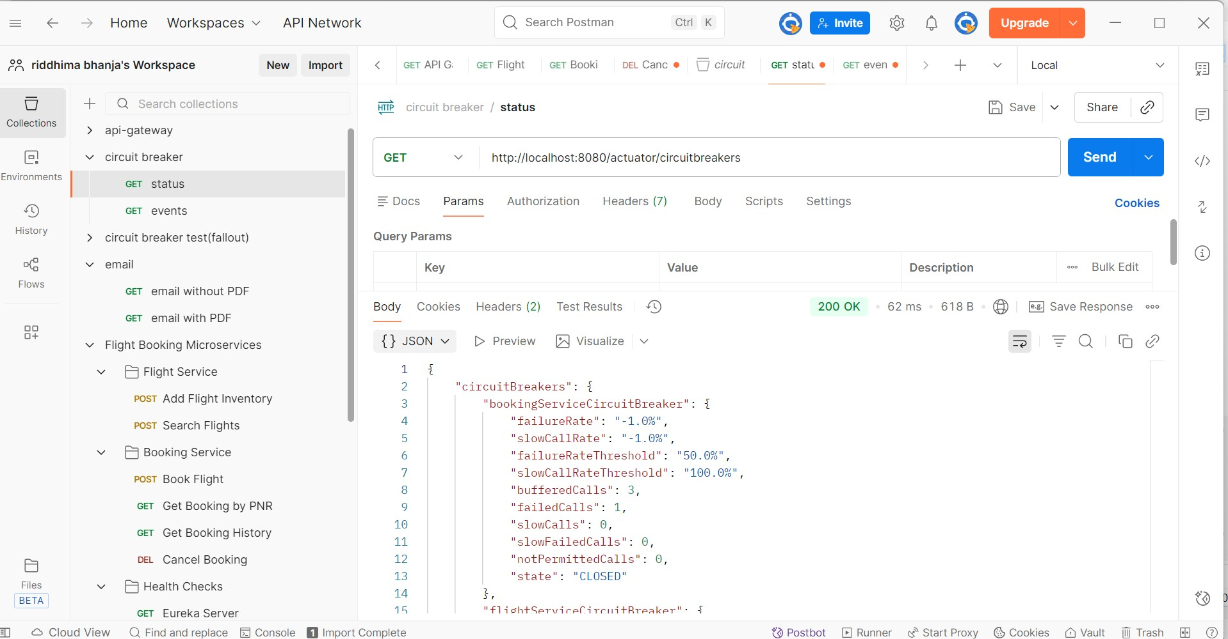

* **Health Check**

**API gateway health:**

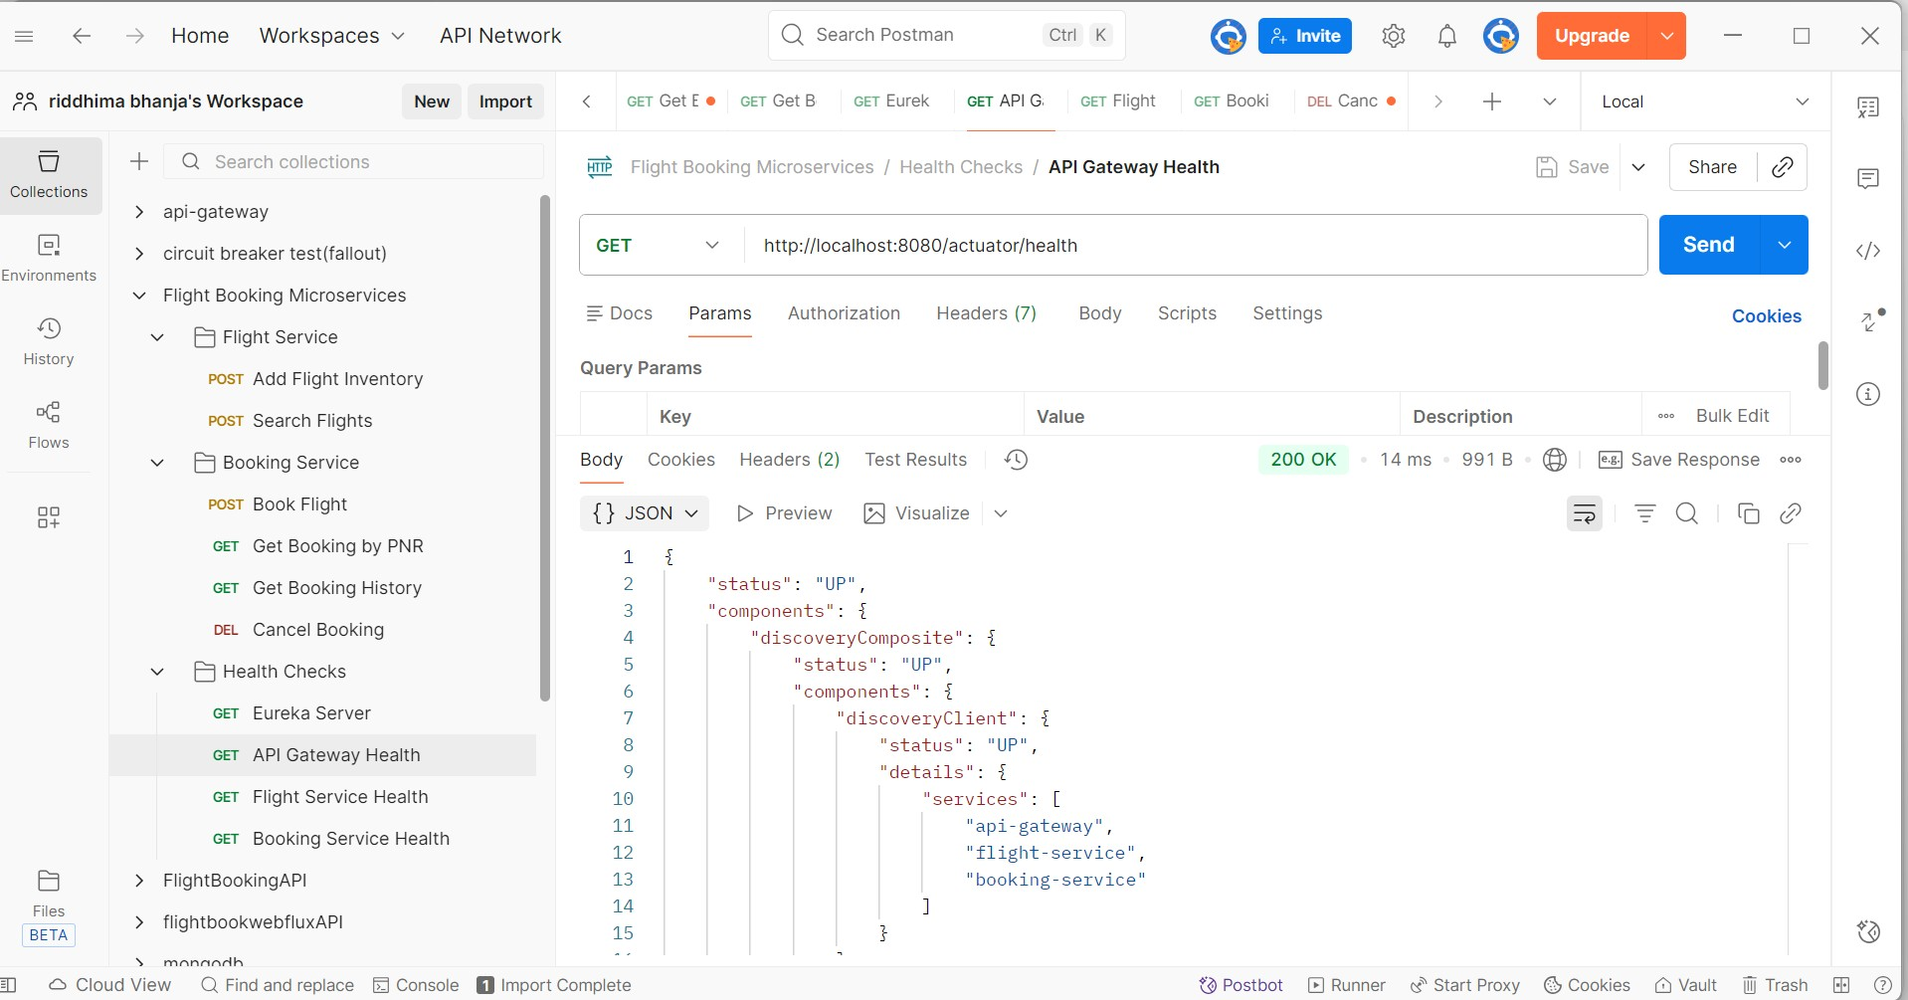

**Booking Service Health:**

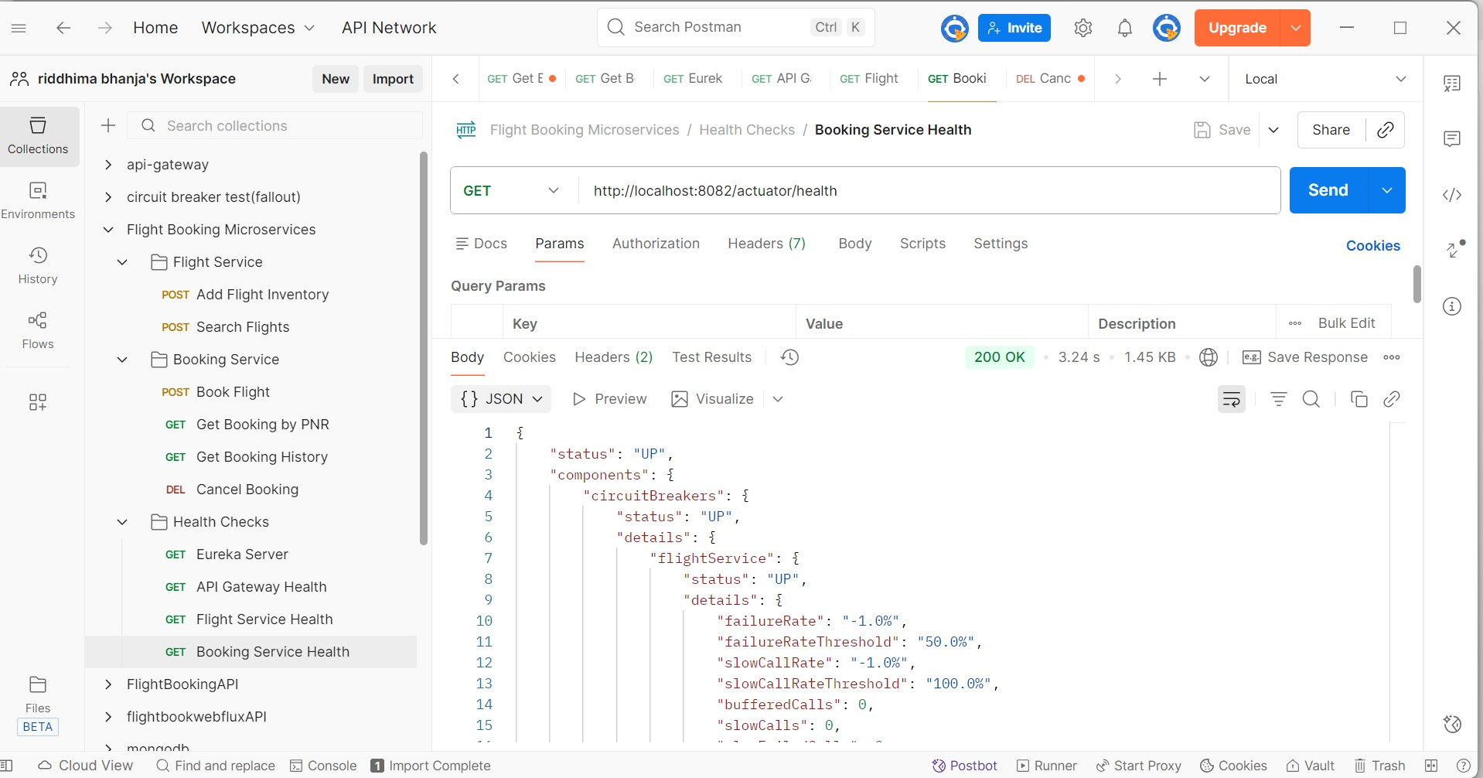

**Eureka server:**

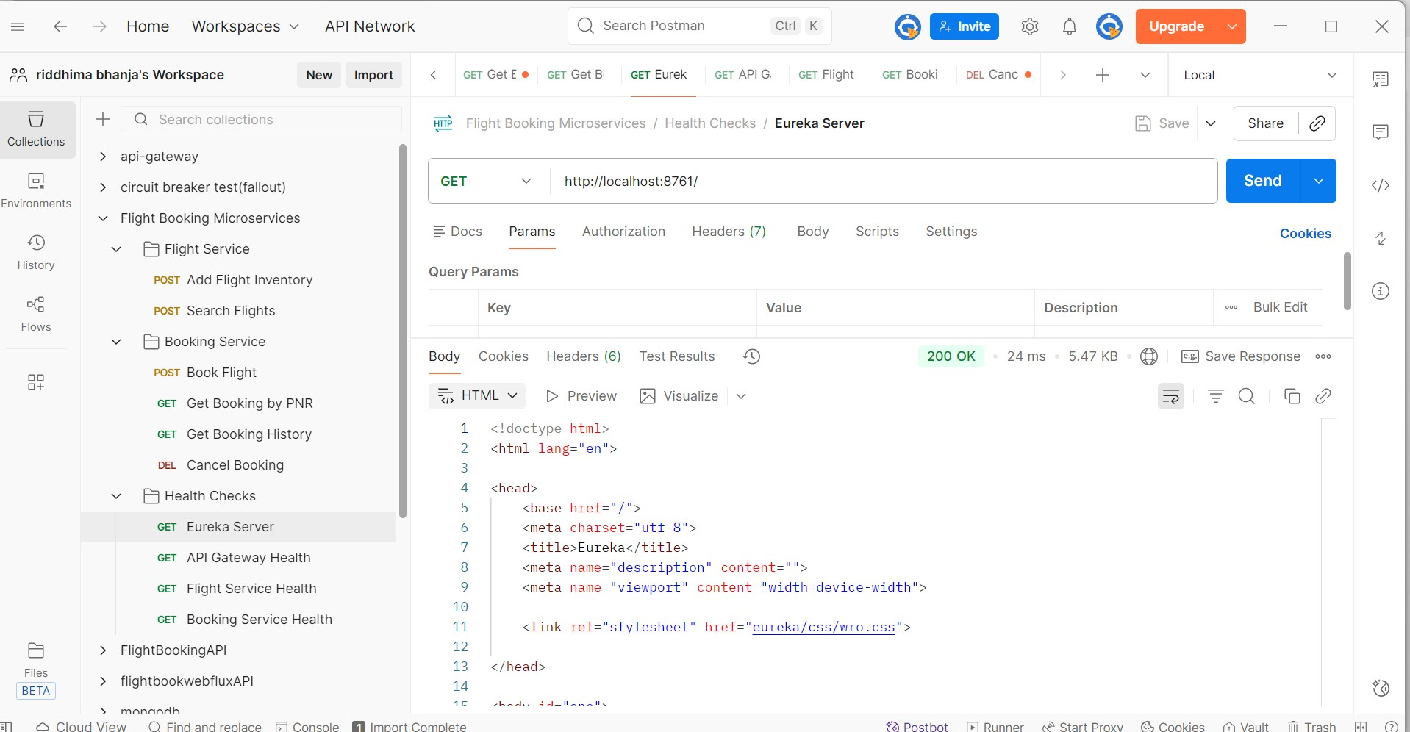

**Flight Service Health:**

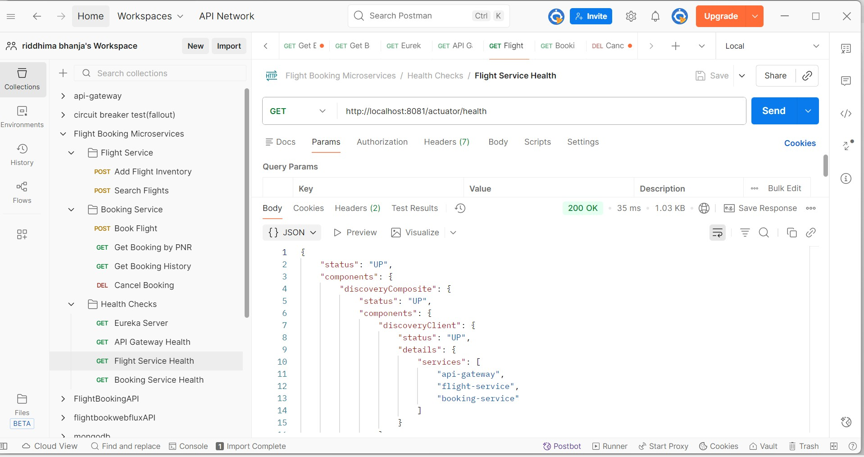

ADD FLIGHT

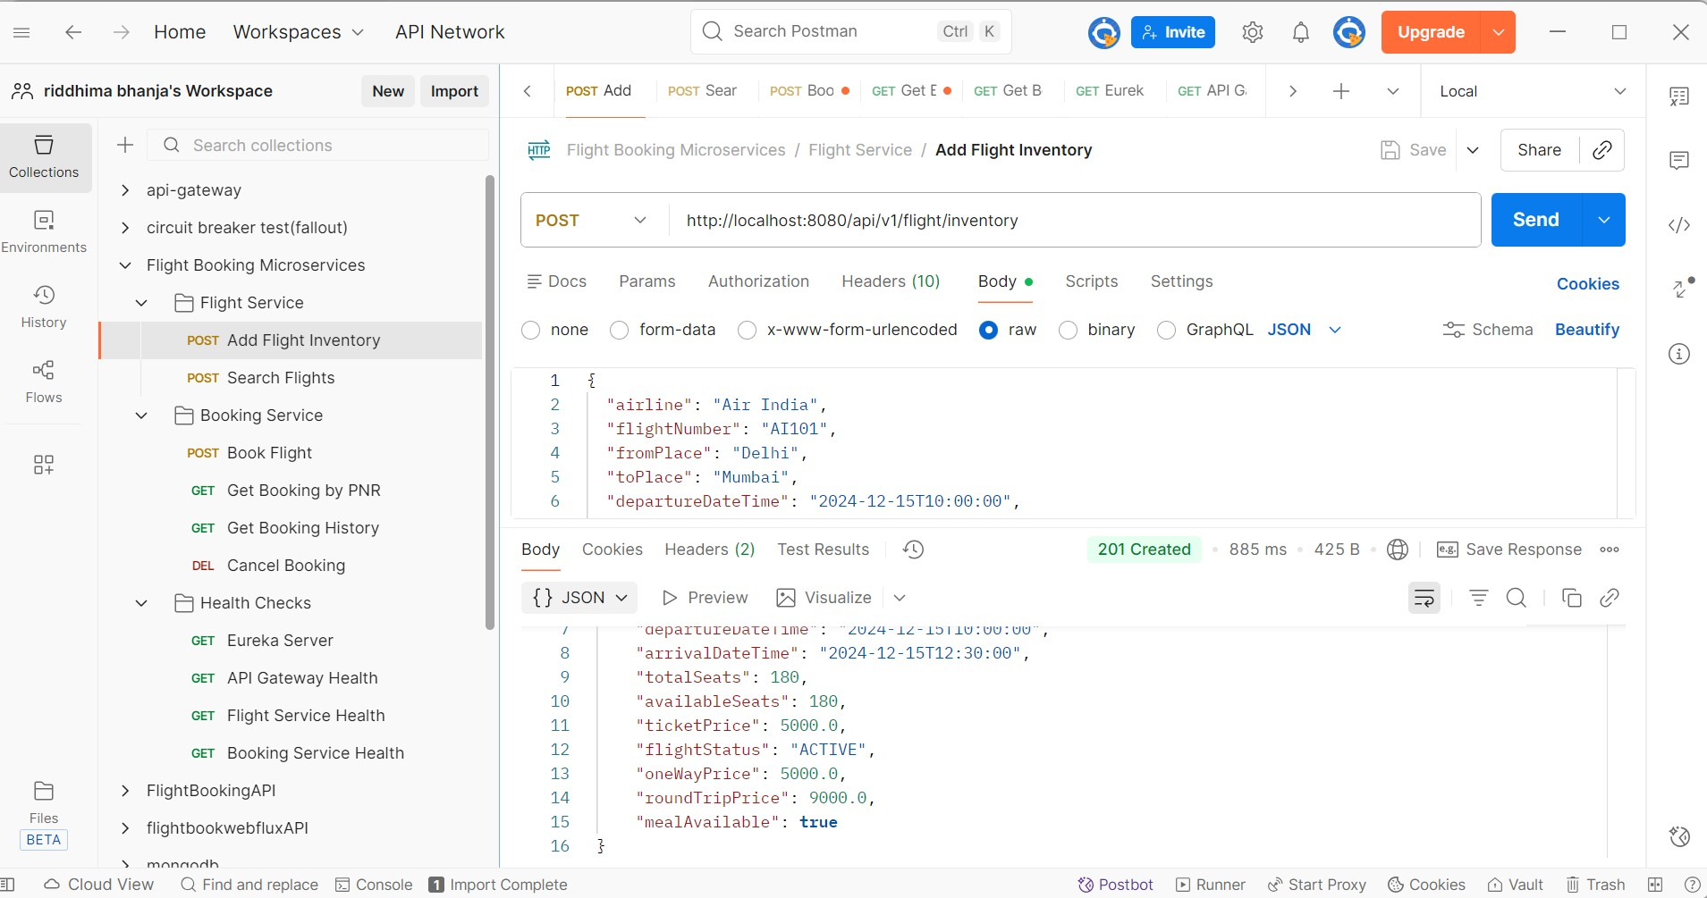

**BOOK FLIGHT**

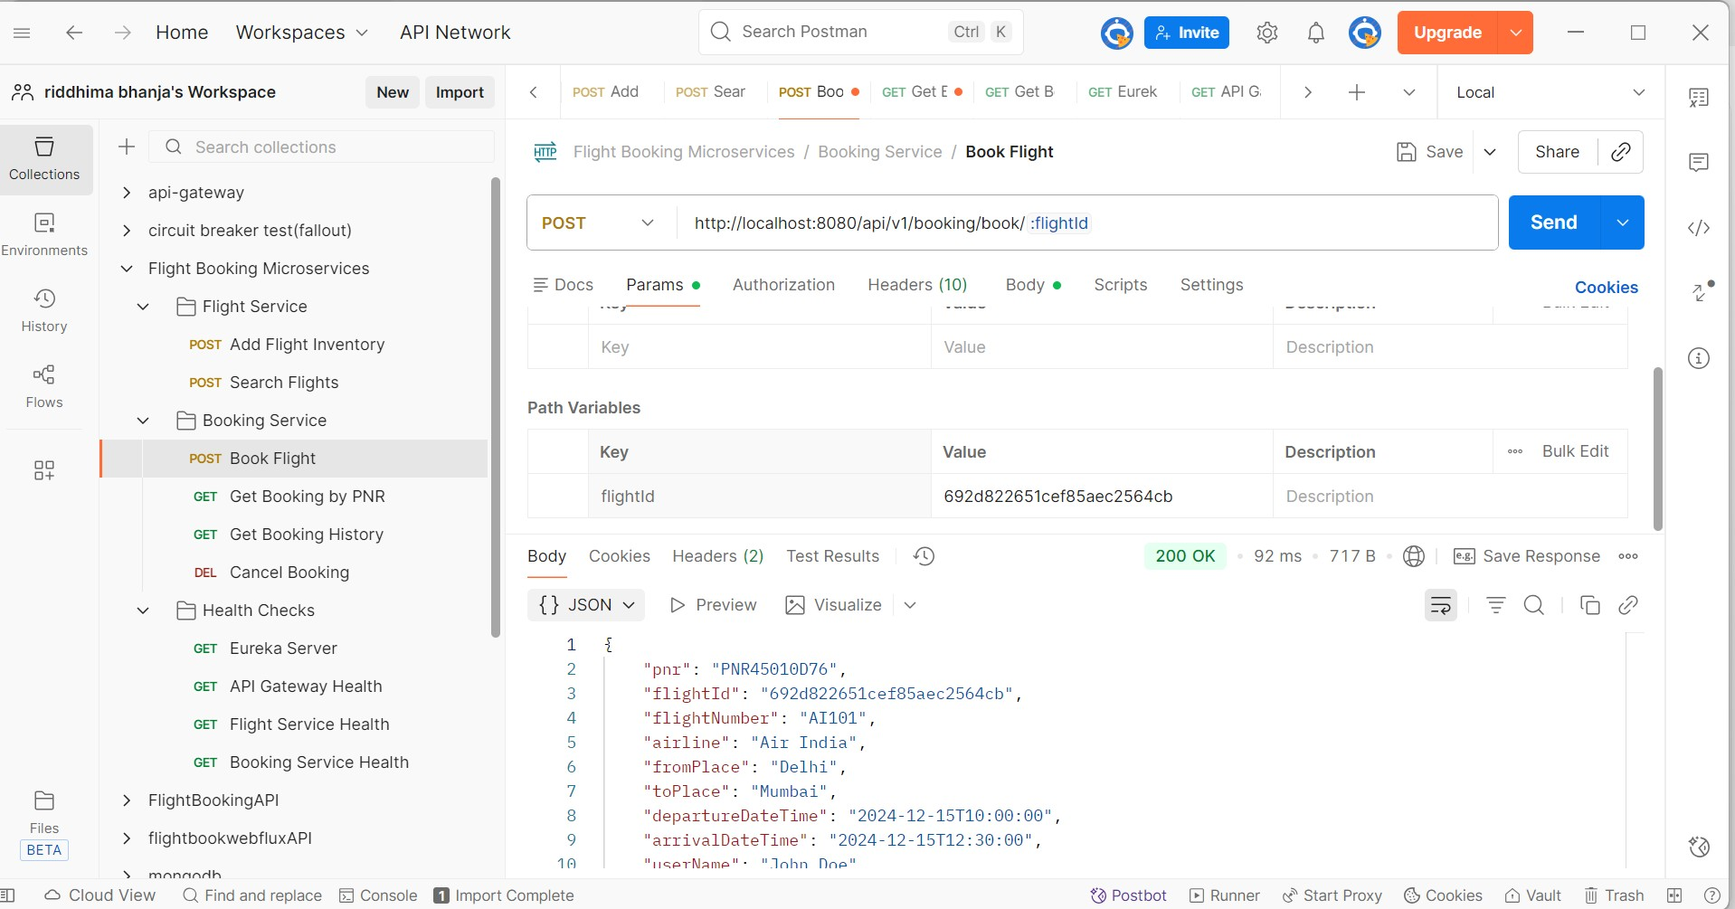

**SEARCH FLIGHTS**

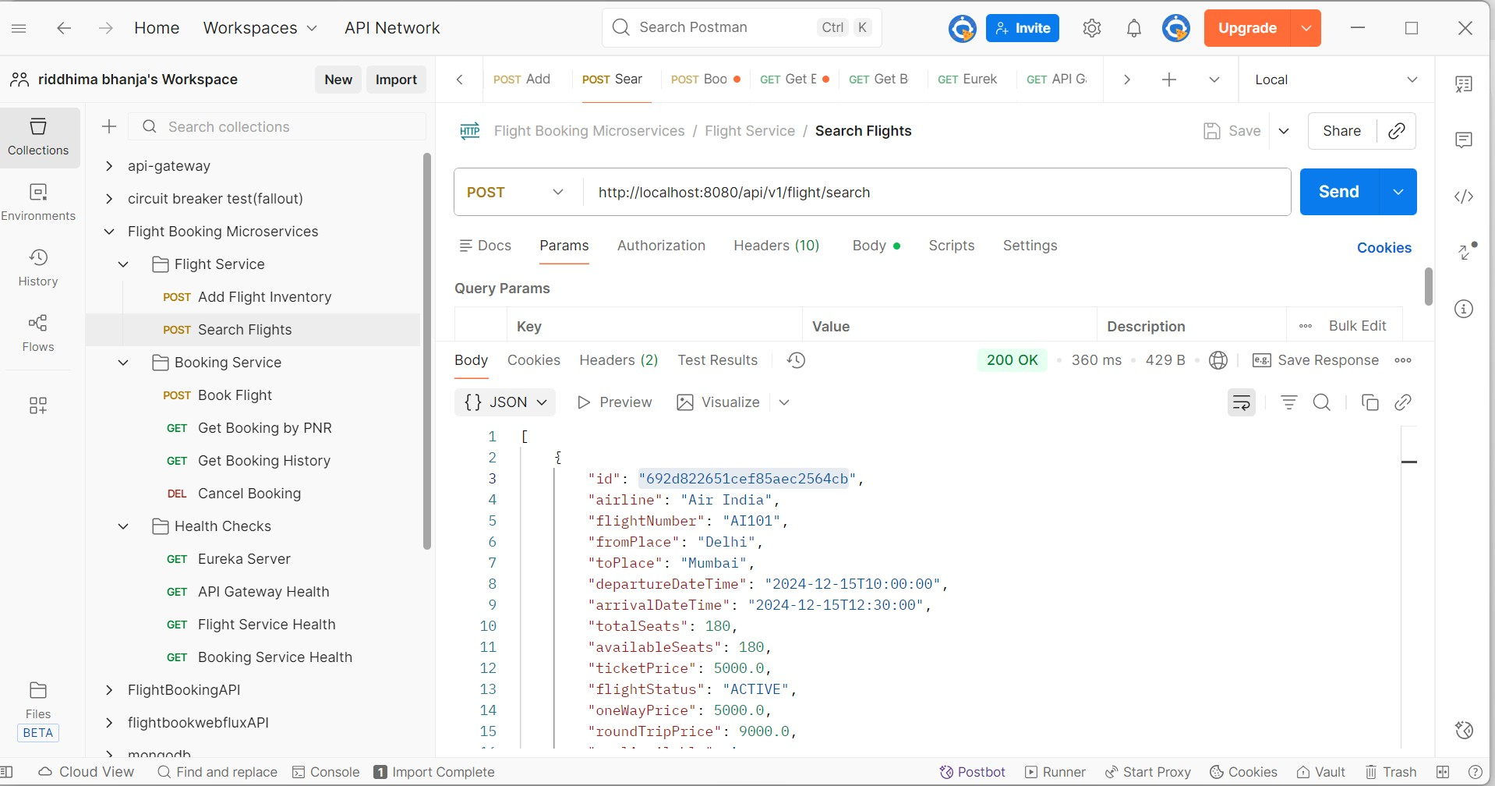

**CANCEL BOOKING**

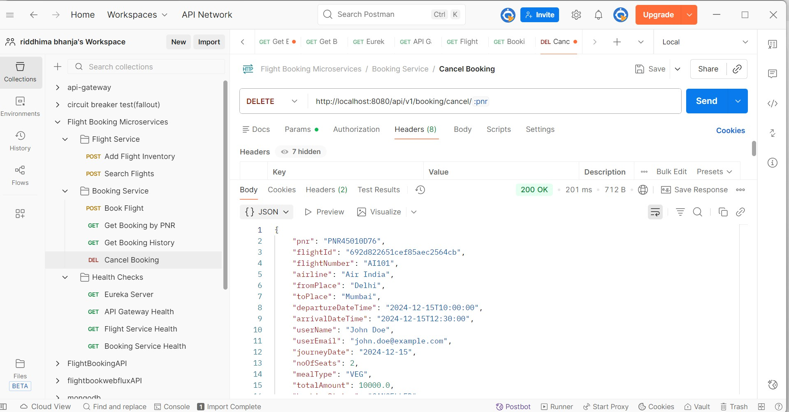

**GET BOOKING BY PNR**

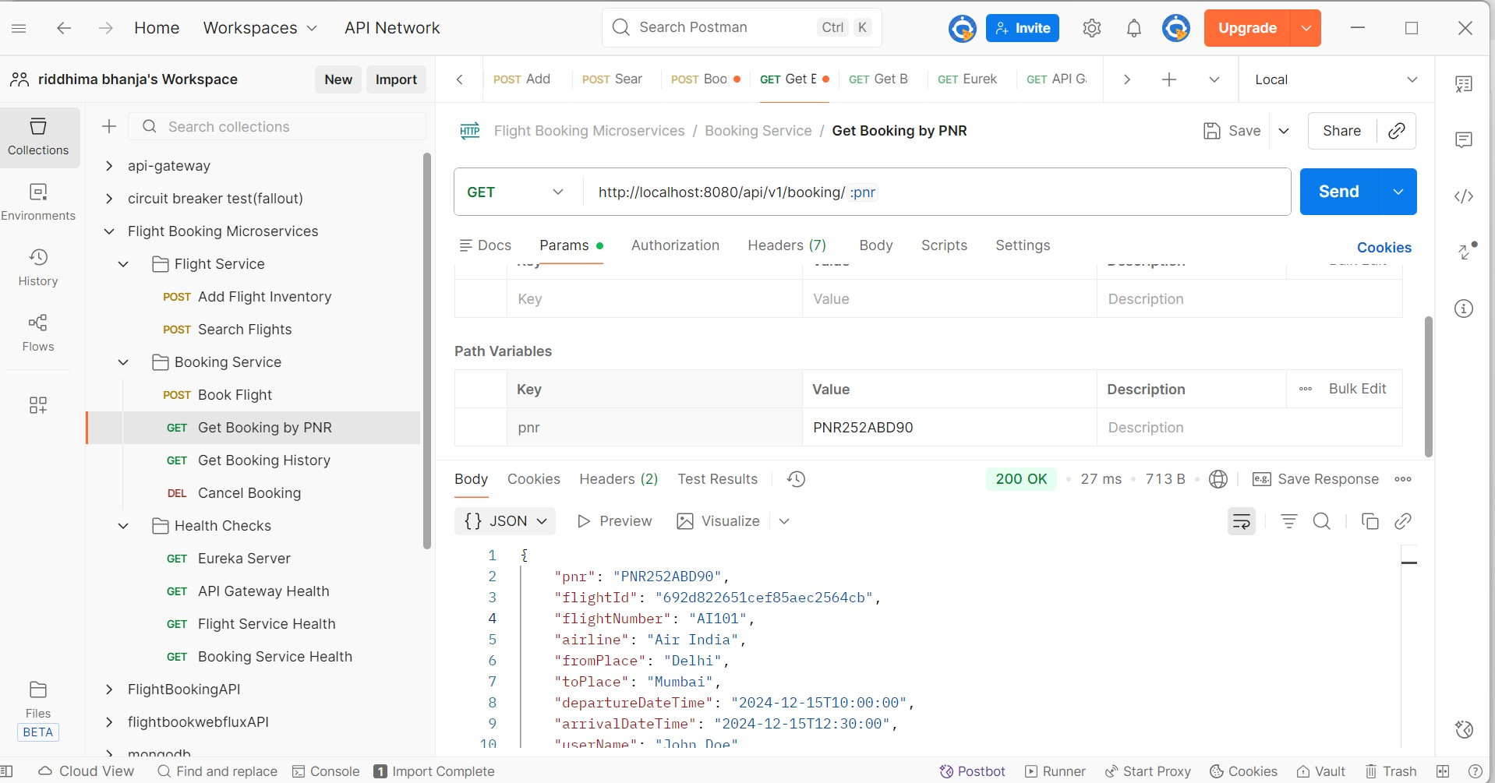

**GET BOOKING HISTORY**

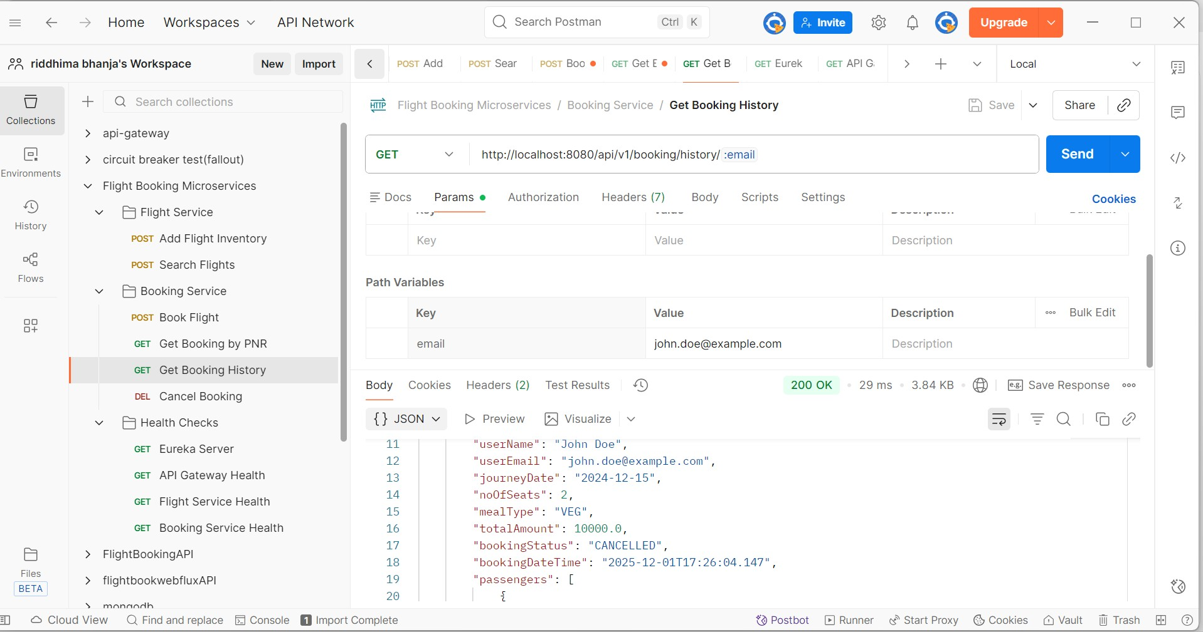

FALLBACK case

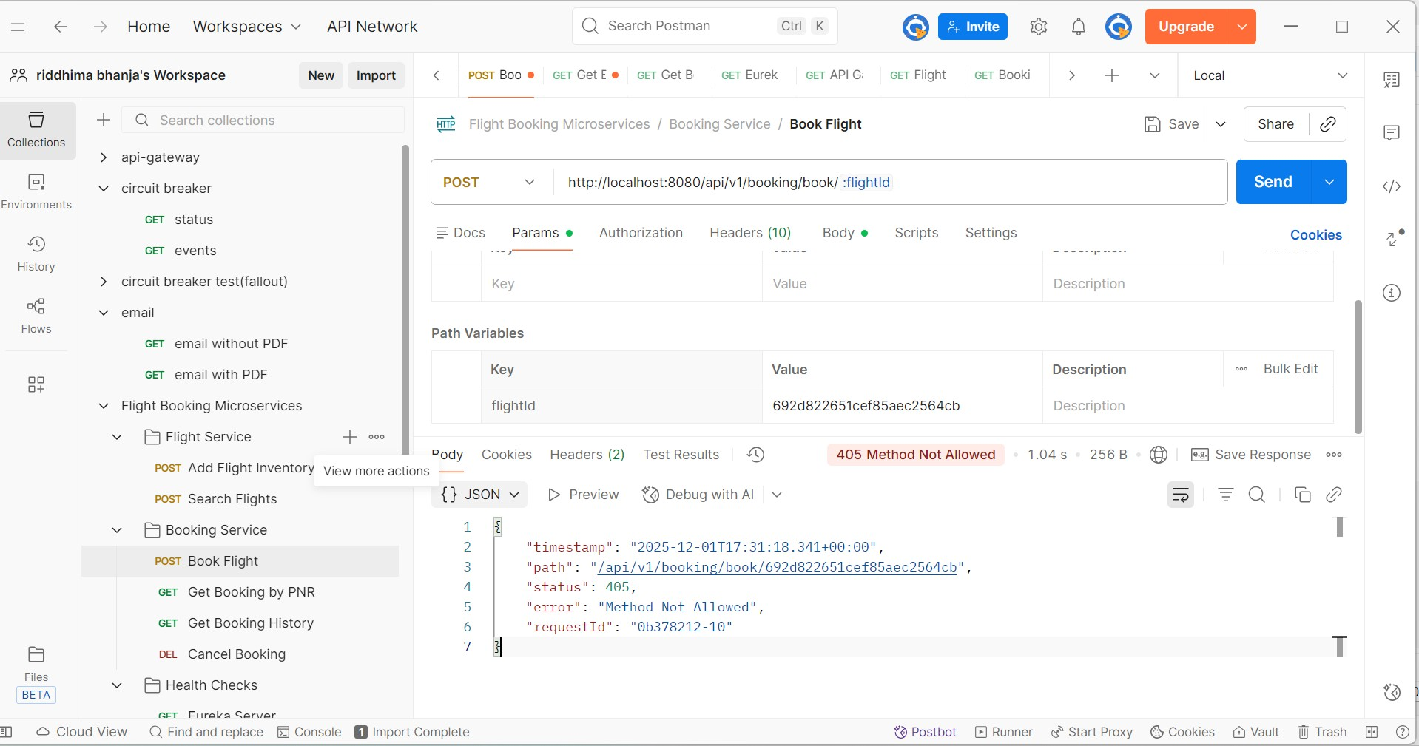

* Jmeter result tree

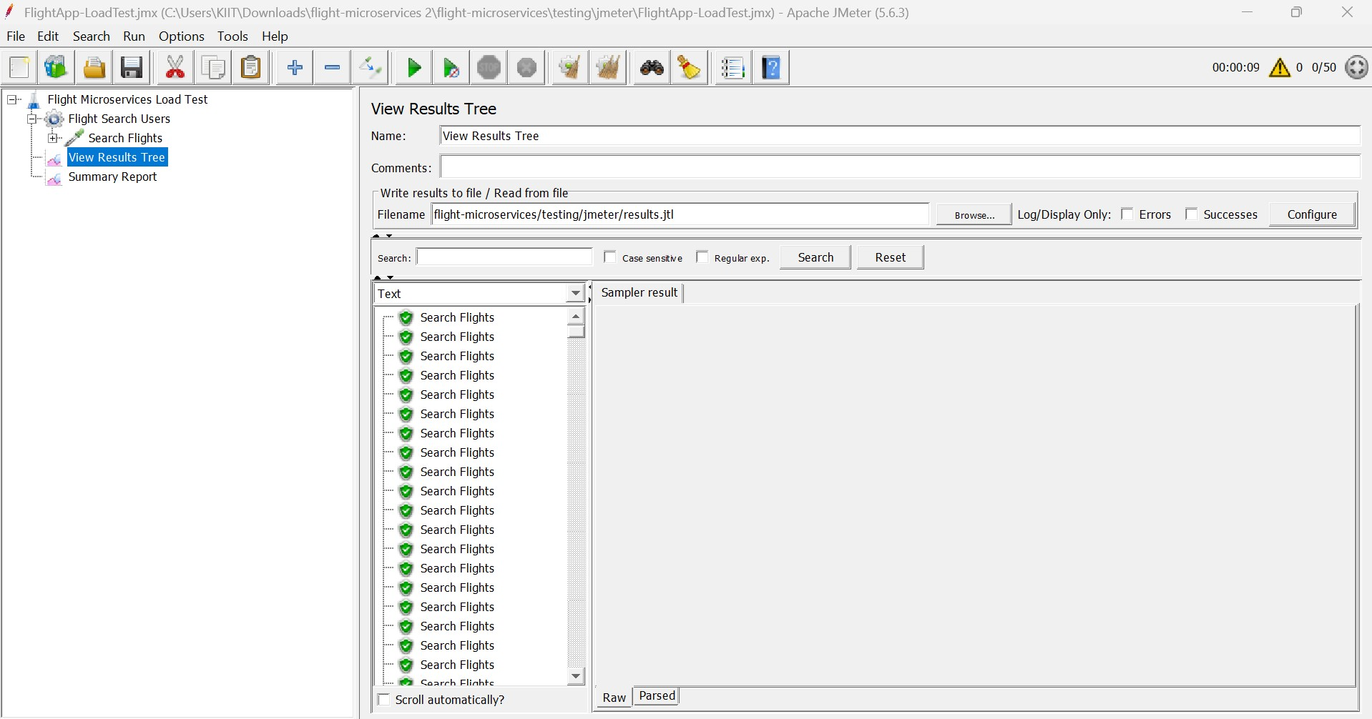

* Jmeter Summary report

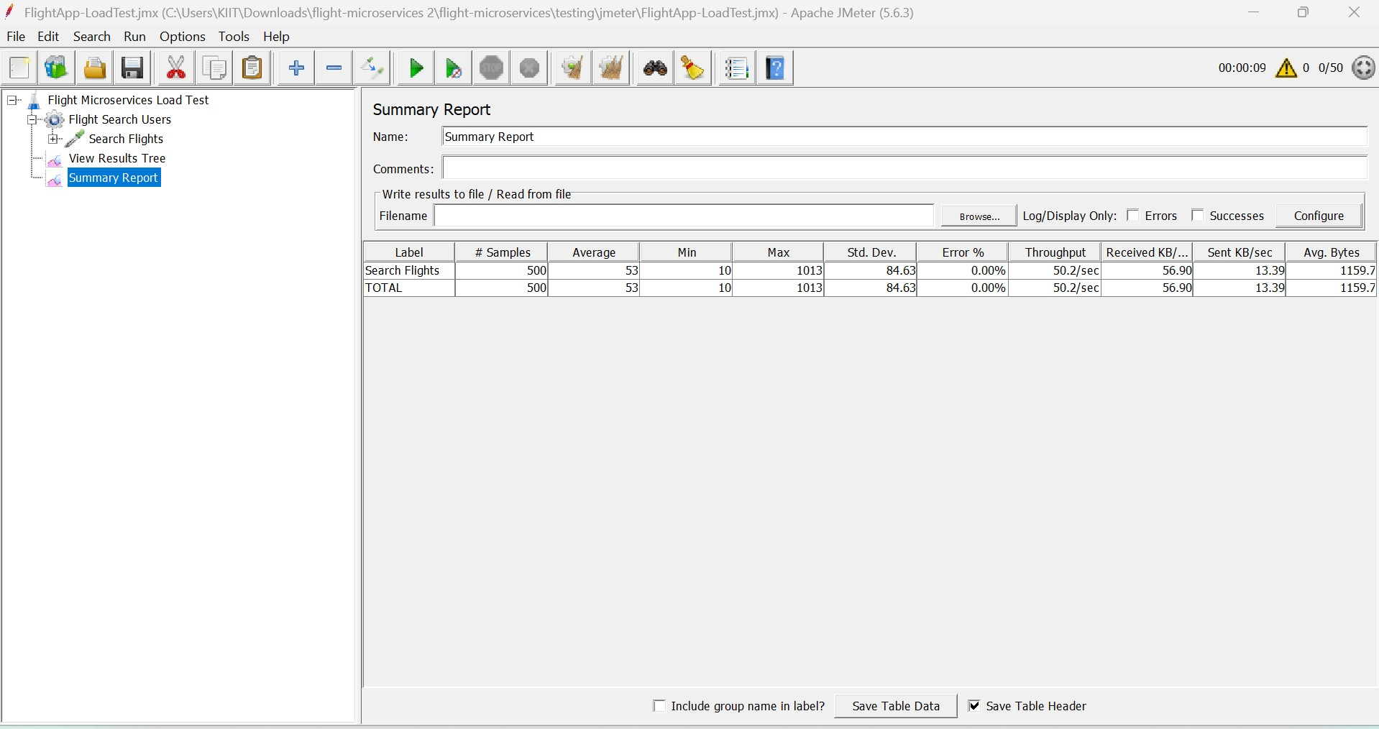

1. Jacoco Code Coverage

* API Gateway

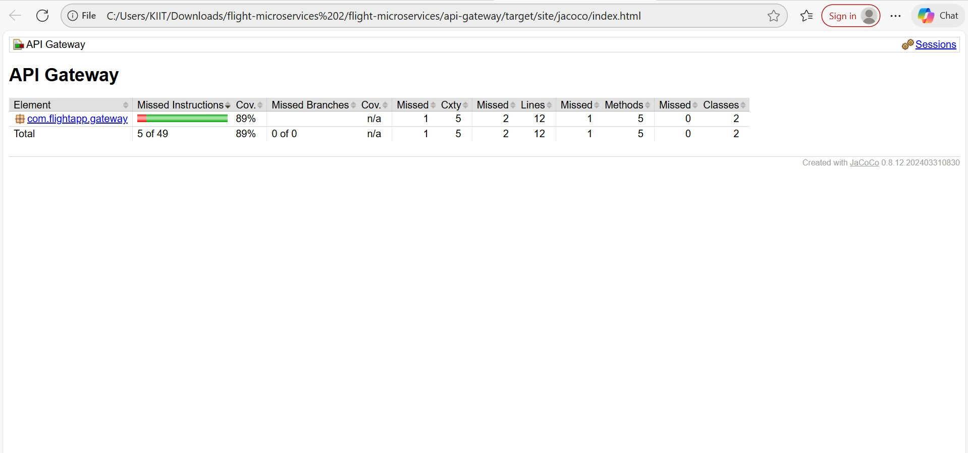

* Flight Service

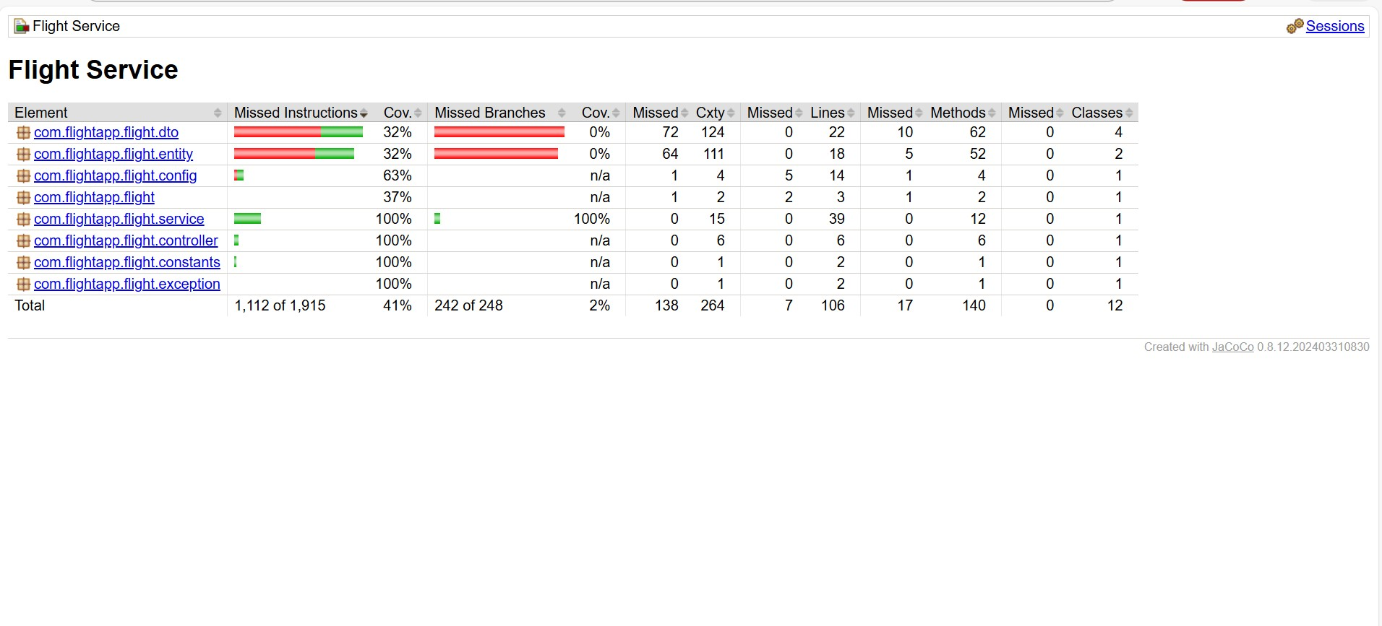

* Booking Service

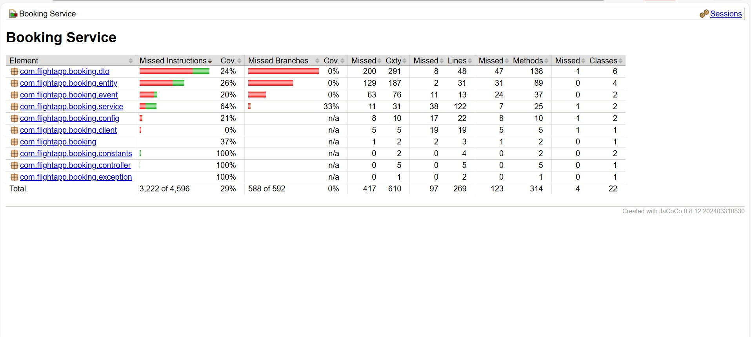

1. **EUREKA DASHBOARD**

